Targeted Modifications for Point-E Project
All modifications are located in: point-e/point_e/enhancements/

Enhancements Overview
- New Data Preprocessing Step
  - File: normalizepointcloud.py
  - Description: Normalizes 3D points to standardize input data before model processing.
  - Purpose: Ensures consistent scaling and positioning of point clouds, enhancing model stability and performance.
- Small Output Post-Processing
  - File: bilateralsmoothing.py
  - Description: Applies bilateral smoothing to reduce noise in the generated point clouds.
  - Purpose: Enhances the visual quality and realism of the 3D output by preserving edges while removing noise.

Integration with Existing Pipeline
The enhancements are managed through applyenhancements.py
The function enhance_point_cloud(pc) is invoked just after the line:
pc = sampler.output_to_point_clouds(samples)[0]
in the existing text2pointcloud and imagetopointcloud scripts, ensuring the point cloud is normalized and smoothed before visualization.
Implementation Details
- Normalizing 3D Points (normalizepointcloud.py)
  - What Changed: Added normalization to preprocess 3D point cloud data.
  - Why: To standardize the point clouds for consistent input scaling.
  - Impact: Improved stability in model performance.
  - Example: Point clouds are scaled to fit within a unit sphere.
- Bilateral Smoothing (bilateralsmoothing.py)
  - What Changed: Implemented bilateral filtering for noise reduction.
  - Why: To enhance visual quality by preserving edge features while removing noise.
  - Impact: Smoother and more realistic 3D outputs.
  - Example: Applied after point cloud generation to refine the model's output.

Results & Metrics
- Informal observations indicate enhanced stability and improved output realism.

text2pointcloud Output
- Results Prior to Enhancements
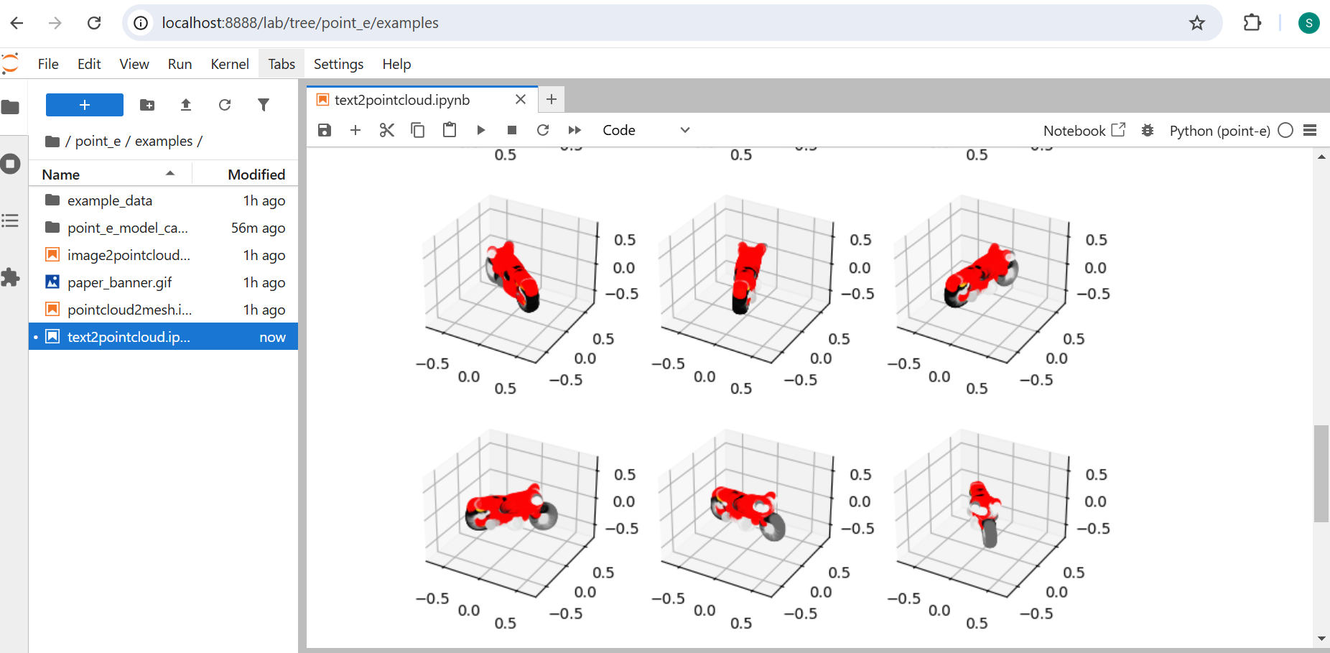
- Results Following Enhancements

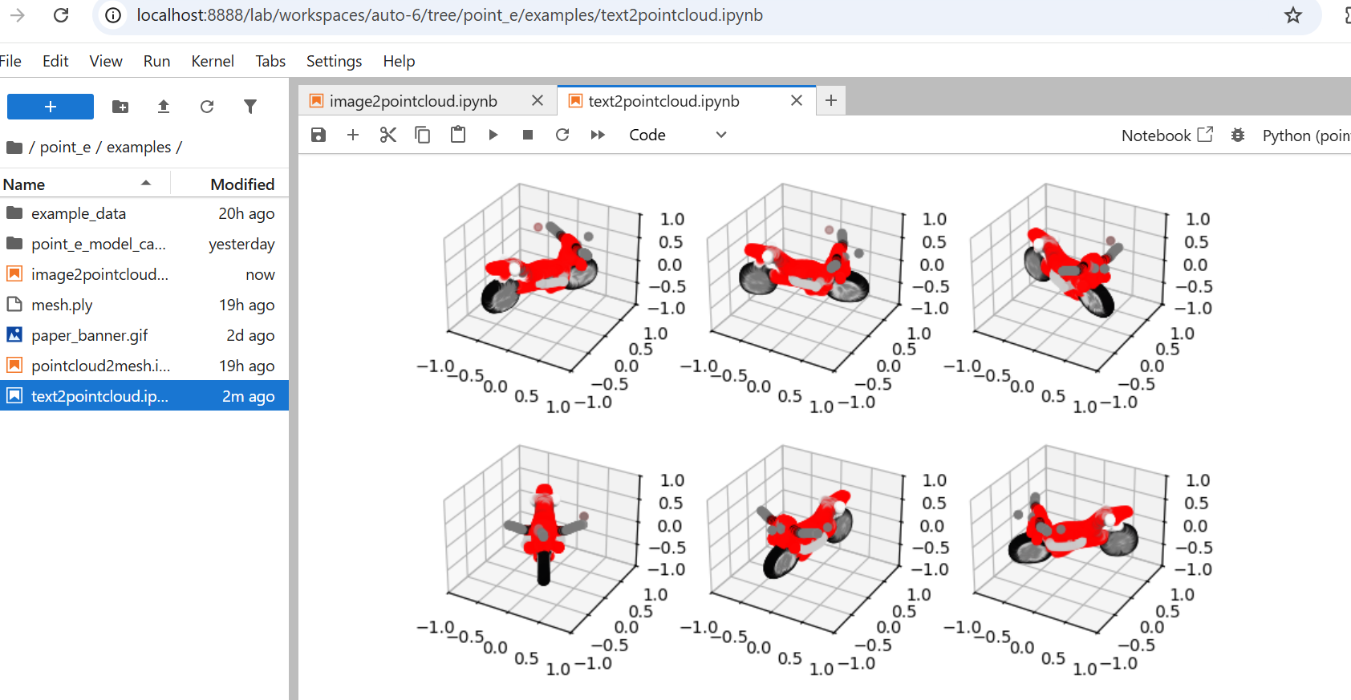

imagetopointcloud Output
- Results Prior to Enhancements
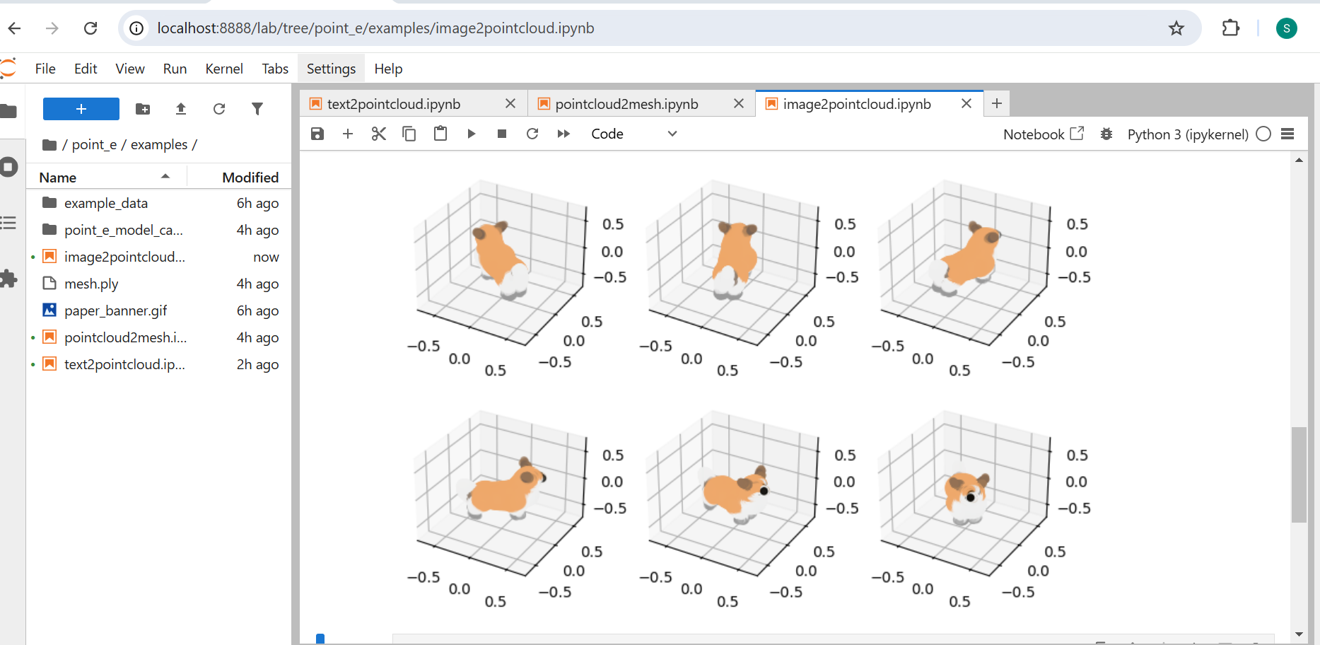
- Results Following Enhancements
